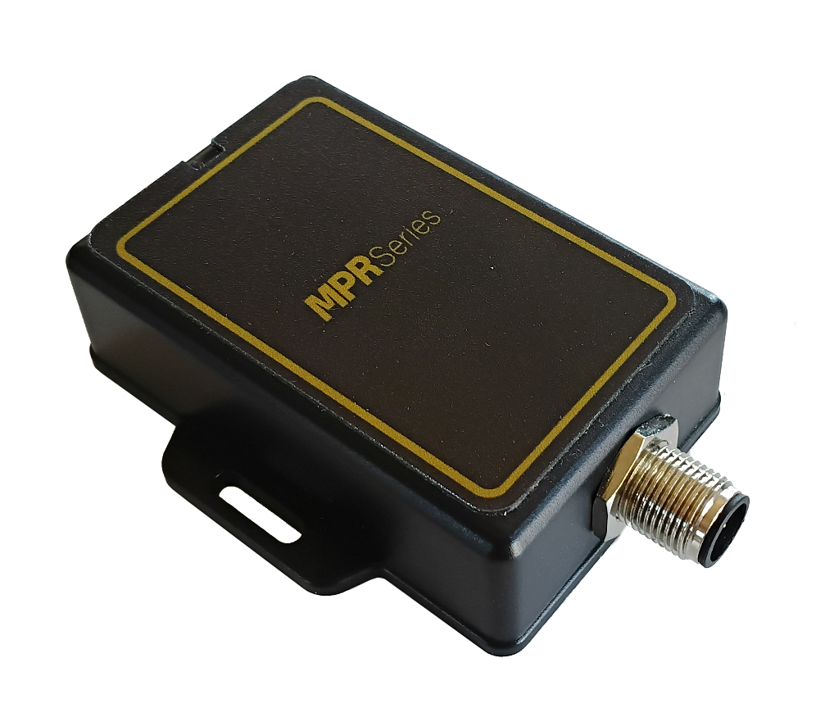

CANopen

iDTRONIC GmbH  Ludwig-Reichling-Straße 4  67059 Ludwigshafen  Germany/Deutschland  Phone: +49 621 6690094-0  Fax: +49 621 6690094-9  E-Mail: info@idtronic.de  Web: idtronic.de | Issue 0.2  – 21. July 2026 –  Subject to alteration without prior notice.  © Copyright iDTRONIC GmbH 2026  Printed in Germany
Contents
1 Function Description 4
1.1 RFID Function 4
1.2 LED Function 4
1.3 LED Control 4
1.4 Configure Bus Address 4
2 Hardware 5
2.1 Pinout 5
2.2 Connector Orientation 5

Function Description

RFID Function
Automatically read UID of ISO14443A and ISO15693 type tags. Send the UID with a size of 4, 7 or 8 Bytes in a single telegram. Repeat this telegram as long as a tag can be detected.

LED Function
After power on, all LEDs shall be OFF.

LED Control
Command: Byte 0: Length of UDS data
Byte 1: UDS Service (0x2E WriteDataByIdentifier)
Bytes 2-3: DID (e.g. 0x6033)
Byte 4: LED Control bits: 0x00 = All LEDs OFF
0x01 = only red
0x02 = only green
0x03 = red and green
So, the coding for the LEDs is in the 2 lowest bits.
Example
>> 04 2E 60 33 02 – light only the green LED

Configure Bus Address
Factory preset address is 0x36.
The address 0x00 is recognized as universal address, so the reader reacts always to it.

Command: Byte 1: Length of UDS data (0x05)
Byte 2: UDS Service (0x2E WriteDataByIdentifier)
Bytes 2-3: DID (0x6091)
Bytes 4-5: Device Address (e.g. 0x0037 = Address 37)
Example
>> 05 2E 60 91 00 37 – sets the device address to 0x37

Hardware

Pinout
1 = Shield, PE
2 = Power Supply +
3 = GND for Power Supply and CAN
4 = CAN High
5 = CAN Low

250 kbs

Connector Orientation
The connector shall be rotated, so that an angled connector will have the cable outlet in direction of the bottom of the housing. Please see the following pictures:
