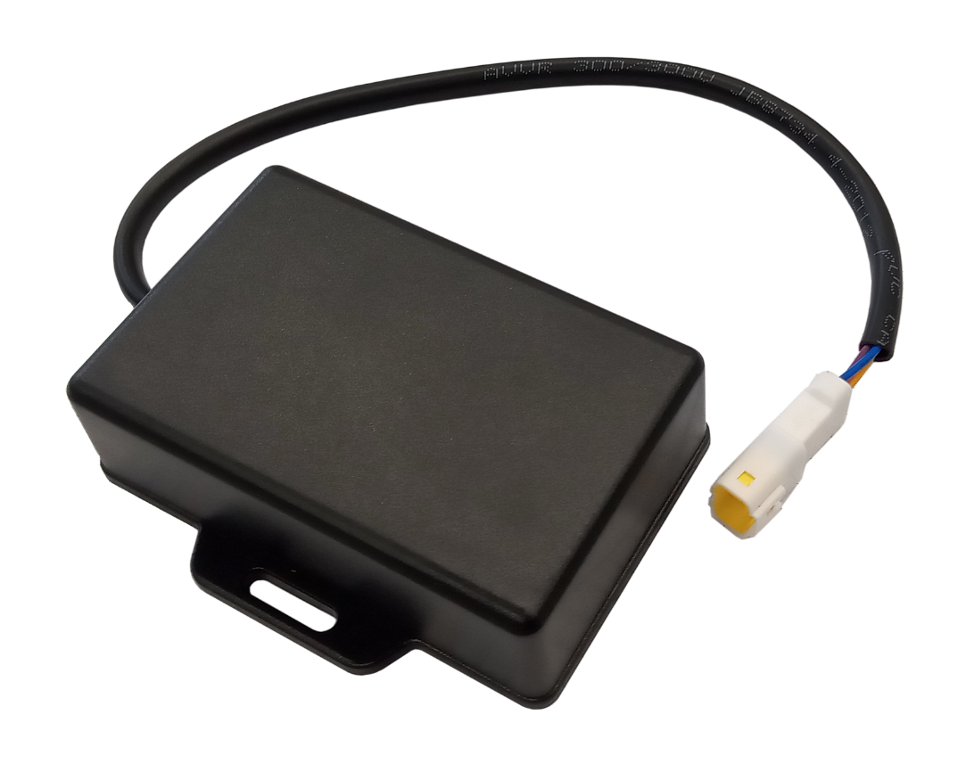

OEM-DES-RFID-Lock
ISO TP on top of CAN-Bus
Examples

iDTRONIC GmbH  Ludwig-Reichling-Straße 4  67059 Ludwigshafen  Germany/Deutschland  Phone: +49 621 6690094-0  Fax: +49 621 6690094-9  E-Mail: info@idtronic.de  Web: idtronic.de | Issue 0.5  – 28. July 2026 –  Subject to alteration without prior notice.  © Copyright iDTRONIC GmbH 2026  Printed in Germany
Contents
1 Overview 5
2 Frame Types of ISO TP 6
2.1 Header (1 or 2 Bytes long) 6
2.2 Single Frame for payload of less or equal than 7 Bytes. 6
2.3 Frames for payload of more than 7 Bytes 6
2.3.1 First Frame (FF) 6
2.3.2 Consecutive Frame (CF) 7
2.4 Flow Control (FC) 7
2.5 Communication Example 8
2.6 Timeout Conditions 9
2.7 Error Detection and Handling 9
3 Example: Transfer of Bootloader Message 10
3.1 Example of Writing Flash for 100 Bytes 10
3.1.1 First Frame (FF) 10
3.1.2 Consecutive Frame (CF) #1 10
3.1.3 Consecutive Frame (CF) #2 10
3.1.4 Consecutive Frame (CF) #3 10
3.1.5 Consecutive Frame (CF) #4 11
3.1.6 Consecutive Frame (CF) #5 11
3.1.7 Consecutive Frame (CF) #6 11
3.1.8 Consecutive Frame (CF) #7 11
3.1.9 Consecutive Frame (CF) #8 11
3.1.10 Consecutive Frame (CF) #9 11
3.1.11 Consecutive Frame (CF) #10 12
3.1.12 Consecutive Frame (CF) #11 12
3.1.13 Consecutive Frame (CF) #12 12
3.1.14 Consecutive Frame (CF) #13 12
3.1.15 Consecutive Frame (CF) #14 12
3.1.16 Consecutive Frame (CF) #15 12
3.2 Successful Response 13
3.3 Error Response 13
4 Test with FW APP_CAN_210513.bin 14
4.1 Example of Writing Flash for 96 Bytes 14
4.1.1 Payload #1 14
4.1.2 Payload #2 14
5 Firmware Update via CAN-Bus 15
5.1 CAN 15
5.1.1 Identifier structure 15
5.1.2 Possible Identifier Values 15
5.1.3 Source and Destination Addresses 15
5.2 Timeout 15
5.3 Protocol 15
5.3.1 General 15
5.3.2 Data Frame 16
5.3.3 CRC Calculation 16
5.4 Commands 16
5.4.1 Readout the Software Version 16
5.4.2 Erase Flashpage 16
5.4.3 Write flash 17
5.4.4 Start application 17
5.5 Firmware Update Procedure 17
5.6 Application Start cycle 17
6 Revision History 18

Overview
The Transport Protocol (TP) of ISO 15765-3 for the CAN-Bus uses 4 types of frames. These are transported in the data field of standard CAN messages.
- Single Frame (SF)
- First Frame (FF)
- Consecutive Frame (CF)
- Flow-Control (FC)
Custom Specific Information
The Data Length Control (DLC) is always 0x08. So, all CAN-Bus messages have a data field of 8 Bytes. Not all payload will fill up the 8 Bytes. Unused Bytes in the data field are filled up with random numbers or with self-incrementing number. This is typical the case in the last Consecutive Frame in a sequence.

Frame Types of ISO TP

Header (1 or 2 Bytes long)
The high nibble of the first data Byte indicates the Frame Type (FT):
- 0x0 = Single Frame (SF)
- 0x1 = First Frame (FF)
- 0x2 = Consecutive Frame (CF)
- 0x3 = Flow Control (FC)

The following one or three nibbles contain the Data Length (DL).

Single Frame for payload of less or equal than 7 Bytes.
A Single Frame (SF) is used, when the payload is less or equal than 7 Bytes. The header is 1 Byte long. The high nibble of the first Byte identifies the frame type. 0x0 indicates a Single Frame.

The low nibble of the first Byte contains the data length.

Header Byte |  | Payload (1…7 Bytes)
High nibble | Low nibble | Byte #1 | Byte #2 | Byte #3 | Byte #4 | Byte #5 | Byte #6 | Byte #7
FT | DL
0x0 | 0x1…7 | 0x00…FF | 0x00…FF | 0x00…FF | 0x00…FF | 0x00…FF | 0x00…FF | 0x00…FF

Frames for payload of more than 7 Bytes

First Frame (FF)
Header (2 Bytes) |  |  |  | Payload (1…6 Bytes)
High nibble | Low nibble | High nibble | Low nibble | Byte #1 | Byte #2 | Byte #3 | Byte #4 | Byte #5 | Byte #6
FT | TDL
0x1 | 0x000…FFF |  |  | 0x00…FF | 0x00…FF | 0x00…FF | 0x00…FF | 0x00…FF | 0x00…FF

If the payload is more than 7 data bytes, segmentation is required. For this purpose, a so-called first frame is sent as the first message. Here there is also a header. However, the header of the First Frame consists of two bytes. The high nibble of the first byte identifies the frame type. 0x1 indicates a First Frame.

The low nibble and the second Byte contain the Total Data Length of the Payload (TDL). So the data length is indicated by 12 bits. This allows 2^12 = 4095 Bytes of payload in total.

The remaining six bytes of the First Frame are filled with data.

Consecutive Frame (CF)
Header Byte |  | Payload (1…7 Bytes)
High nibble | Low nibble | Byte #1 | Byte #2 | Byte #3 | Byte #4 | Byte #5 | Byte #6 | Byte #7
FT | SN
0x2 | 0x1…7 | 0x00…FF | 0x00…FF | 0x00…FF | 0x00…FF | 0x00…FF | 0x00…FF | 0x00…FF

After the First Frame follow as many Consecutive Frames until the entire payload has been sent. In the consecutive frame only the first Byte is used as header Byte.

The high nibble of the first Byte identifies the frame type. 0x2 indicates a Consecutive Frame.

The low nibble of the first Byte counts a sequence number. The value starts with 0x1 for the first Consecutive Frame, counting up to 0xF and starts again at 0x0 (zero).

Flow Control (FC)
These three message types are sent by the sender. The fourth message type, the so-called Flow Control frame, is sent by the receiver in contrast to the previous ones. The flow control frame consists of three Bytes.

The high nibble of the first Byte identifies the frame type. 0x3 indicates a Consecutive Frame.

The low nibble of the first Byte indicates the Flow Status (FS). This informs the sender about the status of the current transmission:
FS = 0x0: Clear to send (CTS)
FS = 0x1: Wait, do not send
FS = 0x2: Overflow, do not send, previous frames may have been dropped by the receiver

The second Byte indicated the Block Size (BS). That is the number of how many Consecutive Frames it may send before the receiver needs time to process them again. A Block Size of 0x00 is a special number meaning: there is no limit, you can send all the messages in one go

The third Byte indicates a Separation Time (ST). This is the minimum distance between consecutive frames that the sender must keep. The information is given in Microseconds (ms).

Header Byte |  | Block Size | Separation Time
High nibble | Low nibble
FT | FS | BS | ST
0x3 | 0x0…2 | 0x00, 0x01…0xFF | 0x00…0xFF

Communication Example
We assume that we have a payload of 35 Bytes and the receiver can only buffer 24 Bytes. The whole process starts from the sender with a First Frame message. It has a one set in the topmost 4 bits. This is followed by twelve bits indicating the Total Data Length. Since we have 35 bytes here, this corresponds to 0x023. After that come the first 6 data bytes.
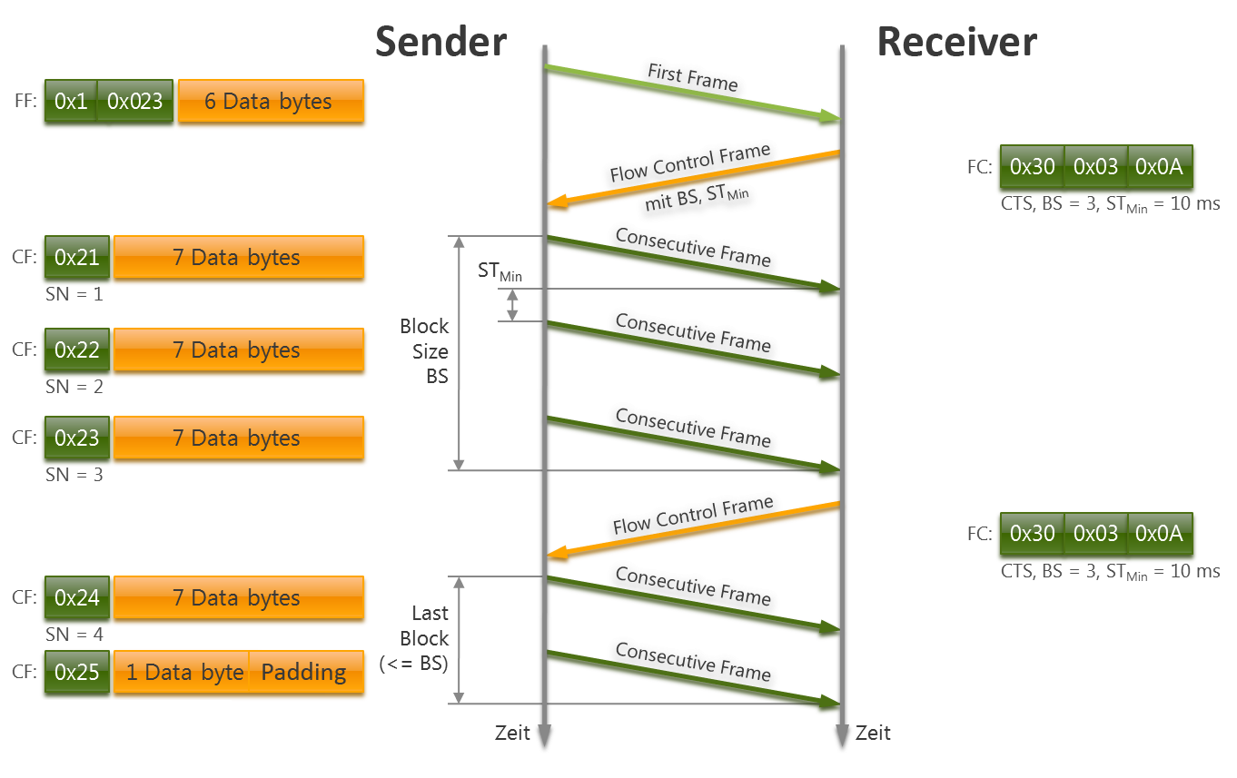
The receiver responds to the first frame by sending back a Flow Control frame in which the high nibble of the first Byte has a value of 0x3. This indicates a Flow Control fram.

We assume that the receiver is able to buffer 24 bytes. It is also ready to receive data. Therefore, the lower nibble of the first Byte has the value of 0x0. This indicates the status ClearToSend. The following byte contains the number of blocks. Here these are 3 blocks ( 24/8 = 3). In the last byte here the minimum separation time is set to ten milliseconds 0x0A.

The sender reacts to the flow control frame by starting to send its consecutive frames with the remaining data. The Consecutive frame starts again with a PCI byte in which the upper 4 bits are set to 2. Then the sequence number one follows, since it is the first Consecutive frame. The remaining 7 bytes of the CAN message are filled with the next 7 user data bytes. Since we have a block size of three in total, this sequence continues like this while keeping the separation time of ten milliseconds: The next consecutive frame follows, the sequence number has changed and the next 7 data bytes are sent. Then follows the third consecutive frame with again 7 data bytes, the sequence number has increased to 3.

Since the block size has been set to three, no further consecutive frame can now follow. The sender waits for the receiver to inform it via a second flow control frame that sending can continue. In our example, the same values as in the first flow control frame are now displayed here. Theoretically, the receiver could ask to wait at this point or it could work with a different block size or a different separation time.

After the actual transmitter has now received this second flow control frame, it continues sending the data block. This is followed by another consecutive frame with sequence number 4 and a last one with sequence number 5. In total, the 35 data bytes have thus been sent successfully.

The process of this segmented data transmission is rather complex, therefore the protocol provides a number of error detection and monitoring mechanisms, which are listed in the following.

Timeout Conditions
For the sender: Distance between the FF message and the FC response: max. 1s.
For the receiver: distance between two CF messages: max. 1s.
If the receiver needs time for processing, it can force a pause with a Flow Control message with Flow Status FS = Wait (0x1), until after max. 1s it requests with another Flow Control message to continue sending (FS = 0x1, ClearToSend) or to wait again.

For diagnostic testers (PC software or other test equipment) BS = 0 and ST = 0 is required, i.e. reception on the tester side effectively without flow control.

Transmitter and receiver monitor the segmented transmission by the corresponding timeouts, the receiver additionally by the sequence number.

Error Detection and Handling
In case of an error, a received message is ignored and the layer above is informed.

There is no error handling in the transport layer, i.e. neither retransmission nor error message.

Monitoring mechanisms include a number of time conditions, i.e. time-out mechanisms. There may be a maximum time interval of one second between the first frame and the flow control frame. Thus, if the receiver does not respond quickly enough with a flow control frame message, the sender knows that something is wrong. Conversely, the receiver monitors the time interval between the consecutive frames. Here, too, there must be a maximum of one second between them. In addition, with segmented transmission, the segment numbers are monitored. If there is an error in the segment numbers or a timeout, the received message is simply ignored. Whether the sender repeats the failed transmission is not defined in the transport layer but must be clarified at the application level.

Example: Transfer of Bootloader Message
The Bootloader communication is the payload of the ISO-TP.

The Flow Control (FC) frames are not shown in the example.

Example of Writing Flash for 100 Bytes
Length | CMD | Data Address | Data Size | Data (Flash Contents) | CRC
0x006E | 0x02 | 0x20000000 | 0x0064 | 0xXX…XX | 0xXX
2 Bytes | 1 Byte | 4 Bytes | 2 Bytes | 100 Bytes | 1 Byte

This gives a Total Data Length of 110 Bytes = 0x6E

First Frame (FF)
Header (2 Bytes) |  |  |  | Payload (1…6 Bytes)
High nibble | Low nibble | High nibble | Low nibble | Byte #1 | Byte #2 | Byte #3 | Byte #4 | Byte #5 | Byte #6
FT | TDL |  |  | Length  MSB | Length  LSB | CMD | Address  MSB | Address | Address
0x1 | 0x06E |  |  | 0x00 | 0x6E | 0x02 | 0x20 | 0x00 | 0x00

Consecutive Frame (CF) #1
Header Byte |  | Payload (1…7 Bytes)
High nibble | Low nibble | Byte #1 | Byte #2 | Byte #3 | Byte #4 | Byte #5 | Byte #6 | Byte #7
FT | SN | Address  LSB | Data Size  MSB | Data Size  LSB | Data #1 | Data #2 | Data #3 | Data #4
0x2 | 0x1 | 0x00 | 0x00 | 0x64 | 0xXX | 0xXX | 0xXX | 0xXX

Consecutive Frame (CF) #2
Header Byte |  | Payload (1…7 Bytes)
High nibble | Low nibble | Byte #1 | Byte #2 | Byte #3 | Byte #4 | Byte #5 | Byte #6 | Byte #7
FT | SN | Data #5 | Data #6 | Data #7 | Data #8 | Data #9 | Data #10 | Data #11
0x2 | 0x2 | 0xXX | 0xXX | 0xXX | 0xXX | 0xXX | 0xXX | 0xXX

Consecutive Frame (CF) #3
Header Byte |  | Payload (1…7 Bytes)
High nibble | Low nibble | Byte #1 | Byte #2 | Byte #3 | Byte #4 | Byte #5 | Byte #6 | Byte #7
FT | SN | Data #12 | Data #13 | Data #14 | Data #15 | Data #16 | Data #17 | Data #18
0x2 | 0x3 | 0xXX | 0xXX | 0xXX | 0xXX | 0xXX | 0xXX | 0xXX

Consecutive Frame (CF) #4
Header Byte |  | Payload (1…7 Bytes)
High nibble | Low nibble | Byte #1 | Byte #2 | Byte #3 | Byte #4 | Byte #5 | Byte #6 | Byte #7
FT | SN | Data #19 | Data #20 | Data #21 | Data #22 | Data #23 | Data #24 | Data #25
0x2 | 0x4 | 0xXX | 0xXX | 0xXX | 0xXX | 0xXX | 0xXX | 0xXX

Consecutive Frame (CF) #5
Header Byte |  | Payload (1…7 Bytes)
High nibble | Low nibble | Byte #1 | Byte #2 | Byte #3 | Byte #4 | Byte #5 | Byte #6 | Byte #7
FT | SN | Data #26 | Data #27 | Data #28 | Data #29 | Data #30 | Data #31 | Data #32
0x2 | 0x5 | 0xXX | 0xXX | 0xXX | 0xXX | 0xXX | 0xXX | 0xXX

Consecutive Frame (CF) #6
Header Byte |  | Payload (1…7 Bytes)
High nibble | Low nibble | Byte #1 | Byte #2 | Byte #3 | Byte #4 | Byte #5 | Byte #6 | Byte #7
FT | SN | Data #33 | Data #34 | Data #35 | Data #336 | Data #37 | Data #38 | Data #39
0x2 | 0x6 | 0xXX | 0xXX | 0xXX | 0xXX | 0xXX | 0xXX | 0xXX

Consecutive Frame (CF) #7
Header Byte |  | Payload (1…7 Bytes)
High nibble | Low nibble | Byte #1 | Byte #2 | Byte #3 | Byte #4 | Byte #5 | Byte #6 | Byte #7
FT | SN | Data #40 | Data #42 | Data #42 | Data #43 | Data #44 | Data #45 | Data #46
0x2 | 0x7 | 0xXX | 0xXX | 0xXX | 0xXX | 0xXX | 0xXX | 0xXX

Consecutive Frame (CF) #8
Header Byte |  | Payload (1…7 Bytes)
High nibble | Low nibble | Byte #1 | Byte #2 | Byte #3 | Byte #4 | Byte #5 | Byte #6 | Byte #7
FT | SN | Data #47 | Data #48 | Data #49 | Data #50 | Data #51 | Data #52 | Data #53
0x2 | 0x8 | 0xXX | 0xXX | 0xXX | 0xXX | 0xXX | 0xXX | 0xXX

Consecutive Frame (CF) #9
Header Byte |  | Payload (1…7 Bytes)
High nibble | Low nibble | Byte #1 | Byte #2 | Byte #3 | Byte #4 | Byte #5 | Byte #6 | Byte #7
FT | SN | Data #54 | Data #55 | Data #56 | Data #57 | Data #58 | Data #59 | Data #60
0x2 | 0x9 | 0xXX | 0xXX | 0xXX | 0xXX | 0xXX | 0xXX | 0xXX

Consecutive Frame (CF) #10
Header Byte |  | Payload (1…7 Bytes)
High nibble | Low nibble | Byte #1 | Byte #2 | Byte #3 | Byte #4 | Byte #5 | Byte #6 | Byte #7
FT | SN | Data #61 | Data #62 | Data #63 | Data #64 | Data #65 | Data #66 | Data #67
0x2 | 0xA | 0xXX | 0xXX | 0xXX | 0xXX | 0xXX | 0xXX | 0xXX

Consecutive Frame (CF) #11
Header Byte |  | Payload (1…7 Bytes)
High nibble | Low nibble | Byte #1 | Byte #2 | Byte #3 | Byte #4 | Byte #5 | Byte #6 | Byte #7
FT | SN | Data #68 | Data #69 | Data #70 | Data #71 | Data #72 | Data #73 | Data #74
0x2 | 0xB | 0xXX | 0xXX | 0xXX | 0xXX | 0xXX | 0xXX | 0xXX

Consecutive Frame (CF) #12
Header Byte |  | Payload (1…7 Bytes)
High nibble | Low nibble | Byte #1 | Byte #2 | Byte #3 | Byte #4 | Byte #5 | Byte #6 | Byte #7
FT | SN | Data #75 | Data #76 | Data #77 | Data #78 | Data #79 | Data #80 | Data #81
0x2 | 0xC | 0xXX | 0xXX | 0xXX | 0xXX | 0xXX | 0xXX | 0xXX

Consecutive Frame (CF) #13
Header Byte |  | Payload (1…7 Bytes)
High nibble | Low nibble | Byte #1 | Byte #2 | Byte #3 | Byte #4 | Byte #5 | Byte #6 | Byte #7
FT | SN | Data #82 | Data #83 | Data #84 | Data #85 | Data #86 | Data #87 | Data #88
0x2 | 0xD | 0xXX | 0xXX | 0xXX | 0xXX | 0xXX | 0xXX | 0xXX

Consecutive Frame (CF) #14
Header Byte |  | Payload (1…7 Bytes)
High nibble | Low nibble | Byte #1 | Byte #2 | Byte #3 | Byte #4 | Byte #5 | Byte #6 | Byte #7
FT | SN | Data #89 | Data #90 | Data #91 | Data #92 | Data #93 | Data #94 | Data #95
0x2 | 0xE | 0xXX | 0xXX | 0xXX | 0xXX | 0xXX | 0xXX | 0xXX

Consecutive Frame (CF) #15
Header Byte |  | Payload (1…7 Bytes)
High nibble | Low nibble | Byte #1 | Byte #2 | Byte #3 | Byte #4 | Byte #5 | Byte #6 | Byte #7
FT | SN | Data #96 | Data #97 | Data #98 | Data #99 | Data #100 | CRC | Padding
0x2 | 0xF | 0xXX | 0xXX | 0xXX | 0xXX | 0xXX | 0xXX | 0xXX

If more than 111 Bytes of payload are transferred more Consecutive Frames are needed. These will start with a Sequence Number of 0x0 again.

Successful Response
Length | CMD | Data | CRC
0x0005 | 0x02 | 0x41 | 0xB8
2 Bytes | 1 Byte | 1 Bytes | 1 Byte

This gives a Total Data Length of 5 Bytes = 0x5. This can be transferred in a Single Frame.

Header Byte |  | Payload (1…7 Bytes)
High nibble | Low nibble | Byte #1 | Byte #2 | Byte #3 | Byte #4 | Byte #5 | Byte #6 | Byte #7
FT | DL | Length  MSB | Length  LSB | CMD | DATA | CRC | Padding | Padding
0x0 | 0x5 | 0x00 | 0x05 | 0x02 | 0x41 | 0xB8 | 0xXX | 0xXX

Error Response
Length | CMD | Data | CRC
0x0005 | 0x02 | 0x46 | 0xB3
2 Bytes | 1 Byte | 1 Bytes | 1 Byte

This gives a Total Data Length of 5 Bytes = 0x5. This can be transferred in a Single Frame.

Header Byte |  | Payload (1…7 Bytes)
High nibble | Low nibble | Byte #1 | Byte #2 | Byte #3 | Byte #4 | Byte #5 | Byte #6 | Byte #7
FT | DL | Length  MSB | Length  LSB | CMD | DATA | CRC | Padding | Padding
0x0 | 0x5 | 0x00 | 0x05 | 0x02 | 0x46 | 0xB3 | 0xXX | 0xXX

Test with FW APP_CAN_210513.bin

Example of Writing Flash for 96 Bytes

Payload #1
Length | CMD | Data Address | Data Size | Data (Flash Contents) | CRC
0x006A | 0x02 | 0x20000000 | 0x0060 | 0x10 0D 00 20 E1 2F 00 08 45 24 00 08 47 24 00 08 4B 24 00 08 4F 24 00 08 53 24 00 08 00 00 00 00 00 00 00 00 00 00 00 00 00 00 00 00 57 24 00 08 59 24 00 08 00 00 00 00 5B 24 00 08 5D 24 00 08 FB 2F 00 08 FB 2F 00 08 FB 2F 00 08 FB 2F 00 08 FB 2F 00 08 FB 2F 00 08 FB 2F 00 08 FB 2F 00 08 | 0xXX
2 Bytes | 1 Byte | 4 Bytes | 2 Bytes | 96 Bytes | 1 Byte

This gives a Total Data Length of 106 Bytes = 0x6A

Payload #2
Length | CMD | Data Address | Data Size | Data (Flash Contents) | CRC
0x006A | 0x02 | 0x20000060 | 0x0060 | 0xFB 2F 00 08 FB 2F 00 08 FB 2F 00 08 FB 2F 00 08 FB 2F 00 08 FB 2F 00 08 FB 2F 00 08 FB 2F 00 08 FB 2F 00 08 FB 2F 00 08 FB 2F 00 08 FB 2F 00 08 FB 2F 00 08 FB 2F 00 08 FB 2F 00 08 FB 2F 00 08 FB 2F 00 08 FB 2F 00 08 FB 2F 00 08 FB 2F 00 08 FB 2F 00 08 FB 2F 00 08 FB 2F 00 08 FB 2F 00 08 | 0xXX
2 Bytes | 1 Byte | 4 Bytes | 2 Bytes | 96 Bytes | 1 Byte

Firmware Update via CAN-Bus
This chapter describes the update of microcontroller Software within the scooter via the ISO-TP protocol. The ISO-TP protocol is implemented over Controller Area Network (CAN) Bus.

CAN
The CAN is using a 2.0B “Extended frame format” with 29bit identifier. The initial speed is defined to 250kbit/s but can be configured within the application to another speed.

Identifier structure
The 29bit Identifiers are structured similar to the Identifier in the application. The structure is described in the following table:
29 bit CAN identifier
28 | 27 | 26 | 25 | 24 | 23 | 22 | 21-11 | 10-0
Priority |  |  | Extended data page | Data Page | TOS |  | Source Address | Destination Address

Possible Identifier Values
The possible values for the CAN identifiers are described in the following table:
Field | Value
Priority | 0b000-0b110
Extended data page | 0b1
Data Page | 0b1
TOS | 0b11
Source | 0-0x7FF
Destination | 0-0x7FF

Source and Destination Addresses
Designation | Address
Tester (PC) | 0x00
KeyReader | 0x36

Timeout
The bootloader has a timeout of 15min. The timeout time gets reset everytime when a CAN command was received, which is for the controller. If the Timeout happens the controller tries to restart. If there is no application it has to stay in the bootloader mode.

Protocol

General
The protocol follows a request/response flow.

Data Frame
Request Frame
The data frame within the ISOTP Message for a request is structured as described in the following table:
Byte 0 | Byte 1 | Byte 2 | Byte 3 to x-1 | Byte x
Length MSB | Length LSB | Command | Data | CRC
Response Frame
The data frame within the ISOTP Message for a response is structured as described in the following table. The command byte is the same as in the request.
Byte 0 | Byte 1 | Byte 2 | Byte 3 to x-1 | Byte x
Length MSB | Length LSB | Command | Data | CRC

CRC Calculation
The CRC is calculated by summing up the whole bytes from length to end of data, then doing a bitwise OR and after that add one.

uint16_t sum = 0;
for (uint8_t byte : data)
{
sum += byte;
}
return ((~sum) + 1);

Commands
There are different commands available.

Readout the Software Version
The command byte for reading out the software versions is 0x00.
Request
For the Request there is no data required.
Response
Within the response there has to be the software version of the bootloader and the application as ASCII format string both separated by a zero termination. E.g. 0x30, 0x2E, 0x32, 0x2E, 0x31, 0x32, 0x33, 0x00, 0x31, 0x2E, 0x31, 0x2E, 0x35, 0x32, 0x31, 0x00 for Bootloader Software Version 0.2.123 and Application Software version 1.1.521. If there is no Firmware in the application the string has to be empty, so a second 0x00 right after the one for the bootloader version.

Erase Flashpage
The command byte for erasing a flashpage is 0x01.
Request
The data in the request contains the flash address.
Data 0 | Data 1 | Data 2 | Data 3
Address MSB | Address | Address | Address LSB
Response
The response is an ASCII ’A’ (0x41) for a successfully received and executed command or a ’F’ (0x46) for any failure in the erase process.

Write flash
The command byte for writing into the flash is 0x02.
Request
The data contains the first the address where to write the data with four bytes, then the byte count with two bytes and after that a maximum of 2048 data bytes to write.
Data 0 | Data 1 | Data 2 | Data 3 | Data 4 | Data 5 | Data x
Address MSB | Address | Address | Address LSB | Size MSB | Size LSB | Data
Response
The response is an ASCII ’A’ (0x41) for a successfully received message or a ’F’ (0x46) for any failure in the write process.

Start application
The command byte for starting the application is 0x22.
Request
For the Request there is no data required.
Response
The response is an ASCII ’A’ (0x41) message if the application can be started or a ’F’ (0x46) for any failure in the starting process, e.g. application CRC check failure.

Firmware Update Procedure
The firmware update procedure is as follows:
1. Enter bootloader from application
2. Request the software versions*
3. Erase the required flash
4. Write the new application into the flash
5. Start the application

If the application can’t be started due to a CRC failure within the application, it has to stay in the bootloader.

* if the software version check shows the version is already up-to-date, the command “start application” can follow without flashing new firmware.

Application Start cycle
After a normal power reset, the bootloader has to follow this startup procedure:
1. Peripheral Initialisation
2. Bootloader enter check
a) Yes: GOTO Bootloader enter
3. Application CRC check
a) CRC not valid: GOTO Bootloader enter
4. Start application

Revision History
Date | Version | Description
2021-05-10 | 0.1 | Initial Draft
2021-05-11 | 0.2 | Complete translation, custom specific information added
2021-05-11 | 0.3 | Example with Bootloader Message added
2021-07-21 | 0.4 | Small additions
2026-07-28 | 0.5 | Commands for FW Update added

